Data science pracs 2,3,4,6,7,8

Prac 2 - Codes-
- Sample t test: Apple
apple <- read.csv(file.choose(), sep = ",", header = TRUE, stringsAsFactors = FALSE) colnames(apple) <- trimws(colnames(apple))
summary(apple)
apple$C1 <- as.numeric(apple$C1) t.test(apple$C1, alternative = "less", mu = 97)
1).CSV file to use-
1 sample t test _apple - 1 sample t test _apple

Output-
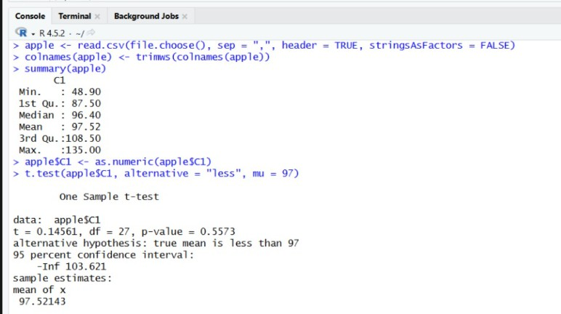

- Sample t test: Male and Female salary
Salary <- read.csv(file.choose(), sep = ",", header = TRUE) summary(Salary)
t.test(Salary$MALES, Salary$FEMALES, alternative = "two.sided",
var.equal = TRUE)

2).CSV file to use-
2 sample t test_malefemalesalary - 2 sample t test_malefemalesalary

Output-
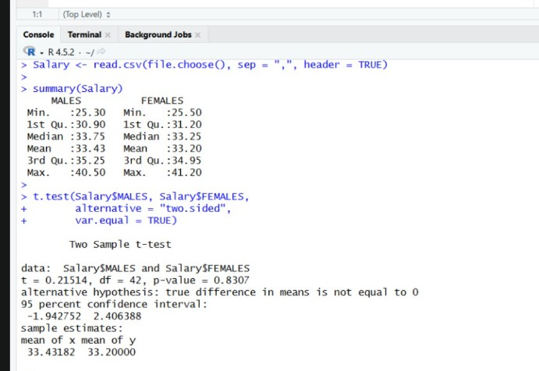

- Paired t test: Poverty level
poverty <- read.csv(file.choose(), sep = ",", header = TRUE)

t.test(poverty$X1, poverty$X2, alternative = "greater", paired = TRUE)

3).CSV file to use-
paired_t_test_povertylevel - paired_t_test_povertylevel
Output-
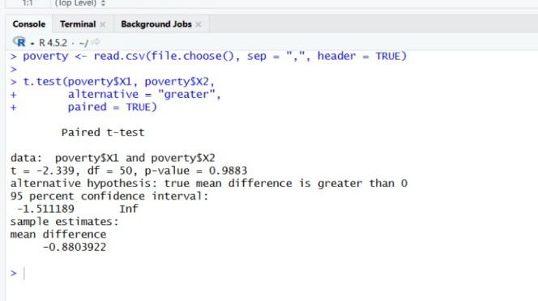

- Paired t test: MIS Report
time1 <- read.csv(file.choose(), sep = ",", header = TRUE) timel <- time1
t.test(timel$time_before, timel$time_after, alternative = "less",
paired = TRUE)

4).CSV file to use-
PAIRED t TEST - PAIRED t TEST

Output
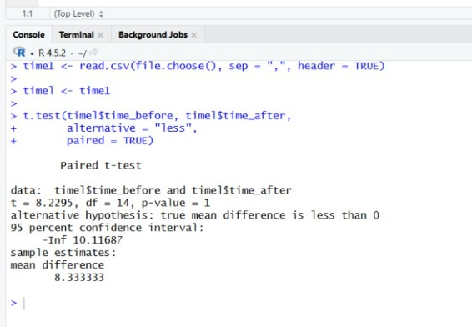

- Correlation test
cor <- read.csv(file.choose(), sep = ",", header = TRUE) summary(cor)
cor.test(cor$aptitude, cor$job_prof, alternative = "two.sided", method = "pearson")

5).CSV file to use-
correlation test (1)

Output
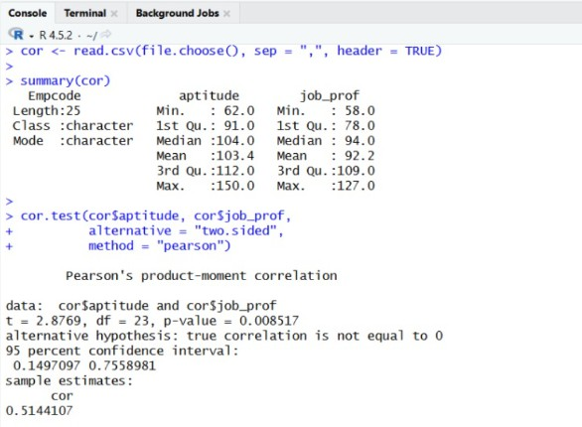

- Variances test
var <- read.csv(file.choose(), sep = ",", header = TRUE) summary(var)
var.test(var$time_g1, var$time_g2, alternative = "two.sided")

6).CSV file to use-
variances (1)

Output
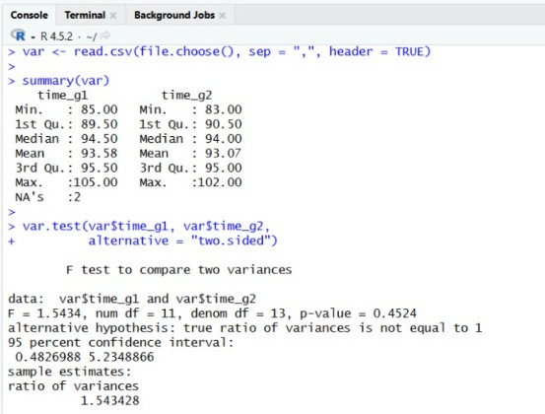

Prac 3- Codes-

ONE WAY ANOVA CODE-
data1 <- read.csv(file.choose(), sep = ",", header = TRUE)

names(data1) summary(data1) head(data1)

anv <- aov(satindex ~ dept, data = data1) summary(anv)
1).CSV file to use-
One way anova

Output
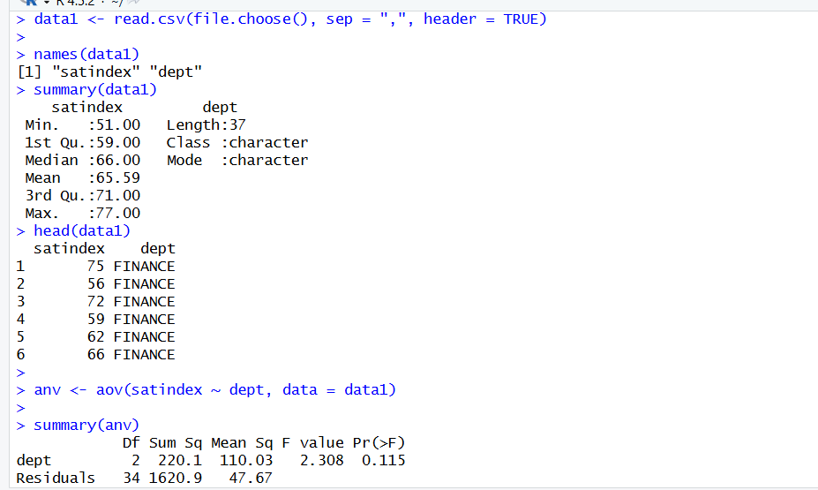

TWO WAY ANOVA CODE-
data2 <- read.csv(file.choose(), sep = ",", header = TRUE)

names(data2) summary(data2)

anv1 <- aov(satindex ~ dept + exp + dept:exp, data = data2) summary(anv1)
2).CSV file to use-
Two way anova

Output-
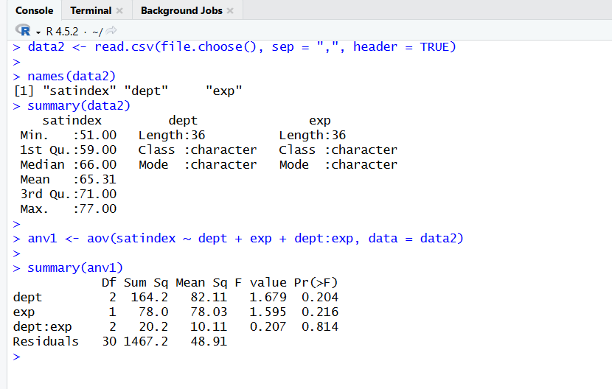

Prac 4 -
- Decision Tree Code-
library(MASS) library(rpart) library(partykit)

data(biopsy)

biopsy <- biopsy[, -1]

names(biopsy) <- c("thick", "u.size", "u.shape", "adhsn",
"s.size", "nucl", "chrom", "n.nuc", "mit", "class")
biopsy.v2 <- na.omit(biopsy) set.seed(123)
ind <- sample(2, nrow(biopsy.v2), replace = TRUE,
prob = c(0.7, 0.3))

biop.train <- biopsy.v2[ind == 1, ] biop.test <- biopsy.v2[ind == 2, ]
str(biop.test$class) set.seed(123)
tree.biop <- rpart(class ~ .,
data = biop.train, method = "class")

print(tree.biop$cptable)

cp <- tree.biop$cptable[which.min(tree.biop$cptable[, "xerror"]), "CP"] prune.tree.biop <- prune(tree.biop, cp = cp)
plot(as.party(tree.biop))

plot(as.party(prune.tree.biop))

rparty.test <- predict(prune.tree.biop,
newdata = biop.test, type = "class")

table(rparty.test, biop.test$class)

After the code install a package-
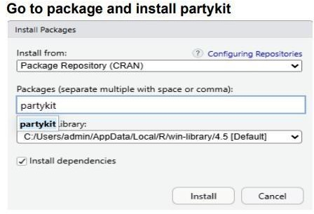
Output-
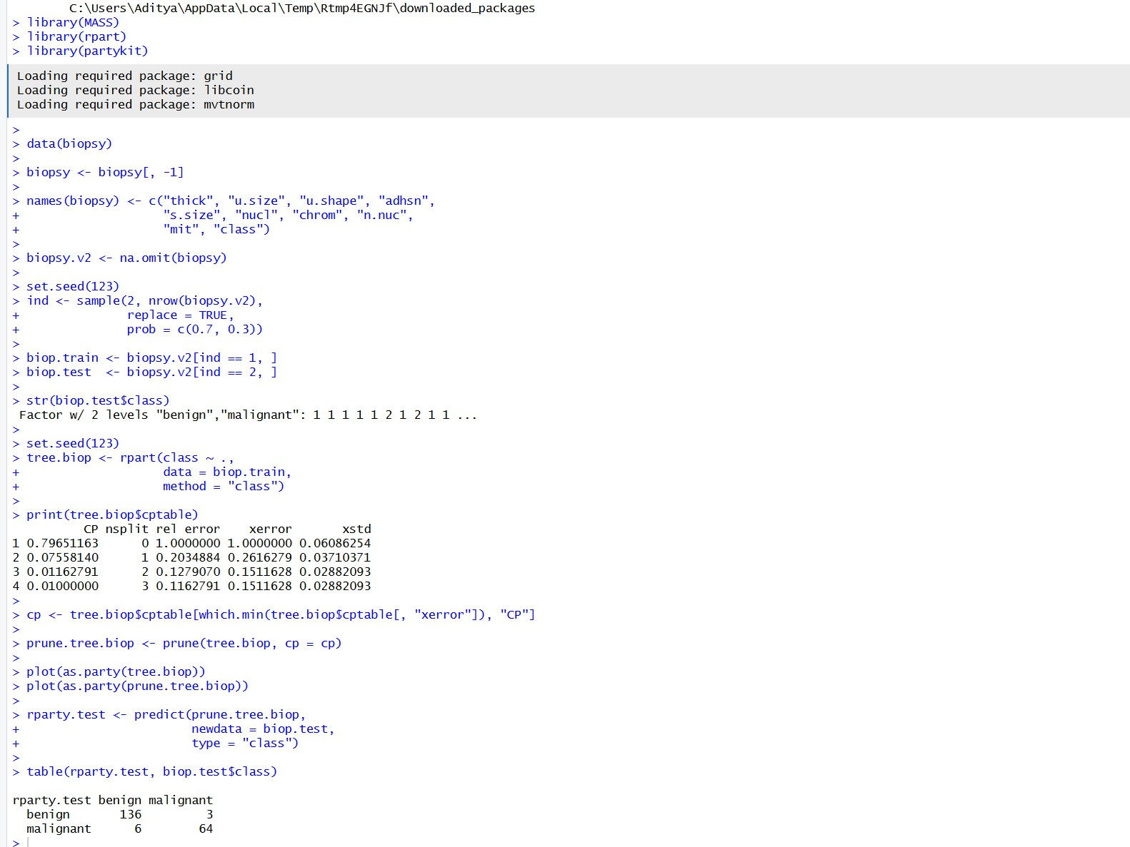

Plot output-
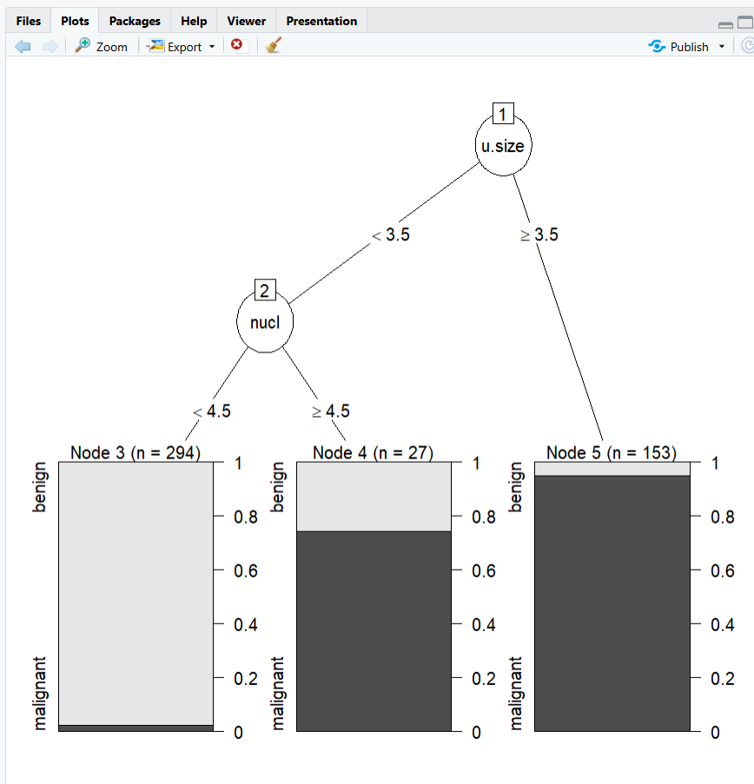

Prac 6-
Logistic Regression- Code-
library(MASS) data(biopsy)

head(biopsy) str(biopsy)

biopsy$ID = NULL

names(biopsy) = c("thick","usize","ushape","adhsn", "celsiz","nucl","chrom",
"nuclus","mit","class") colSums(is.na(biopsy))
biopsy1 = na.omit(biopsy)

set.seed(123)
ind = sample(2, nrow(biopsy1), replace = TRUE, prob = c(0.7, 0.3))

train = biopsy1[ind == 1, ] test = biopsy1[ind == 2, ]

fullfit = glm(class ~ ., family = binomial, data = train) summary(fullfit)

test$prob = predict(fullfit, newdata = test, type = "response")

test$predict = rep("benign", nrow(test)) test$predict[test$prob < 0.5] = "malignant"

table(test$predict, test$class) mean(test$predict == test$class) library(ROCR)

ROCRpred = prediction(test$prob, test$class) ROCRperf = performance(ROCRpred, "tpr", "fpr")

plot(ROCRperf, colorize = TRUE)

After the code install package
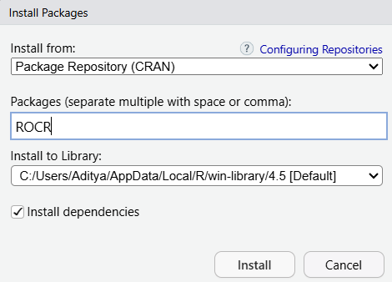

Output-
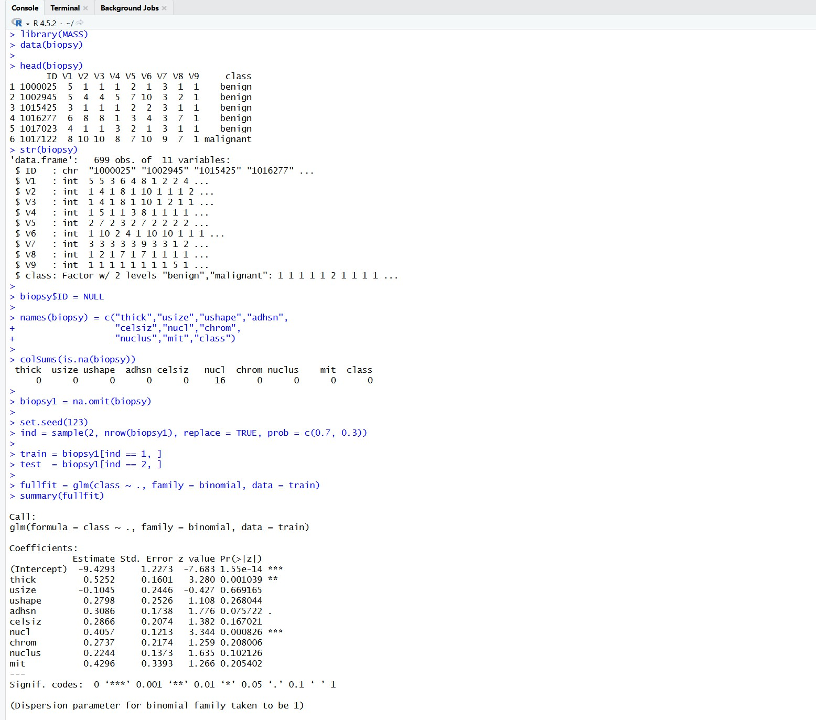
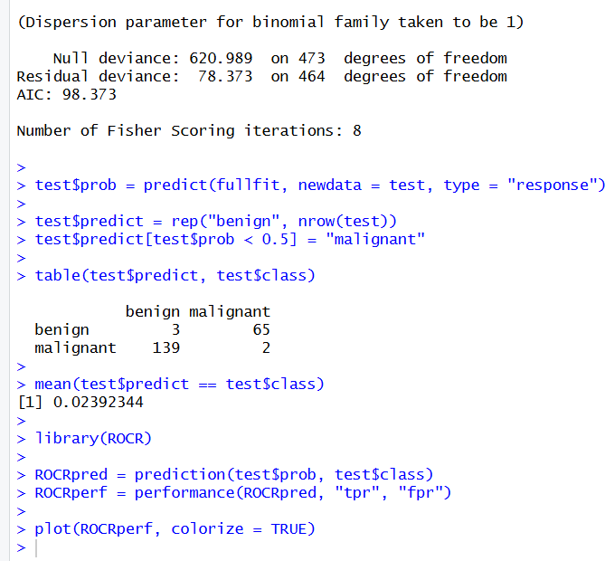

Plot Output-
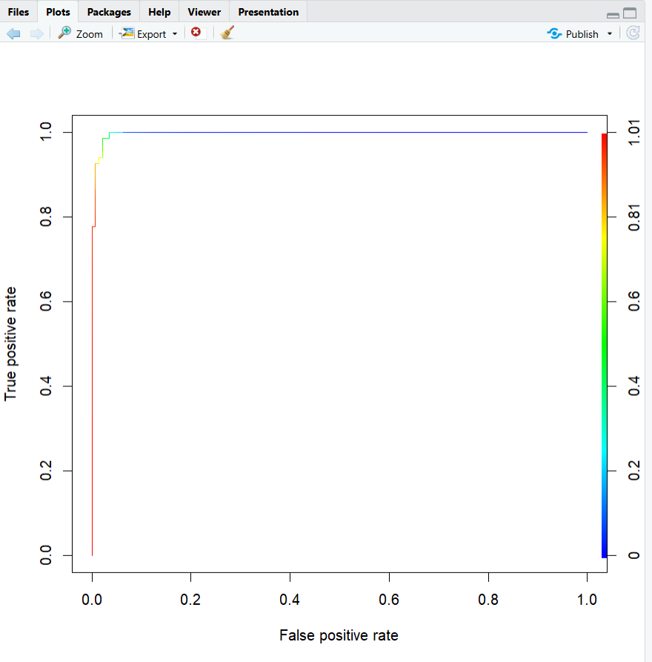

Prac 7
Time Series Forecasting Code-
library(hflights) library(data.table)

dt <- data.table(hflights)
dt[, date := ISOdate(Year, Month, DayofMonth)] daily <- dt[, list(
N = .N,
Delays = sum(ArrDelay, na.rm = TRUE), Cancelled = sum(Cancelled),
Distance = mean(Distance)
), by = date] str(daily)
After the code install packages -
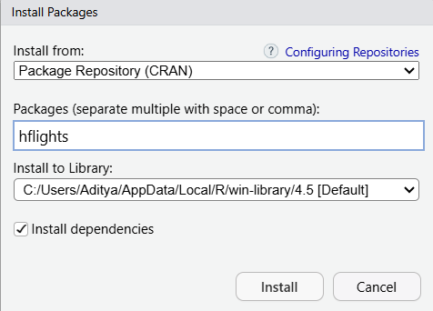

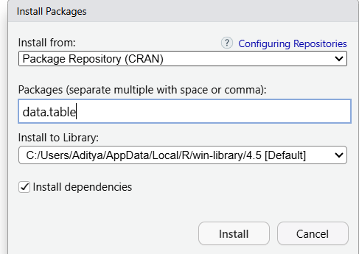

OUTPUT-
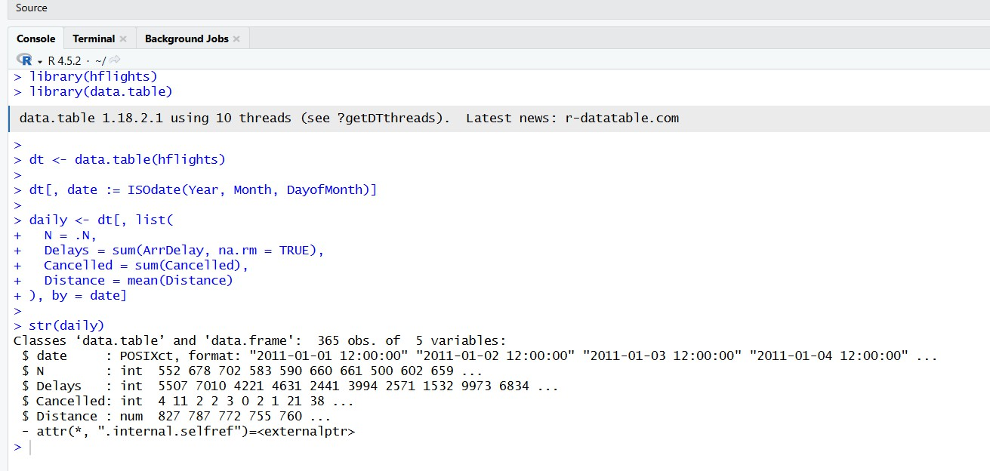
After this Output type in the Output This line -
nts <- ts(daily$N, frequency = 7) plot(nts)

It will show you plot output-
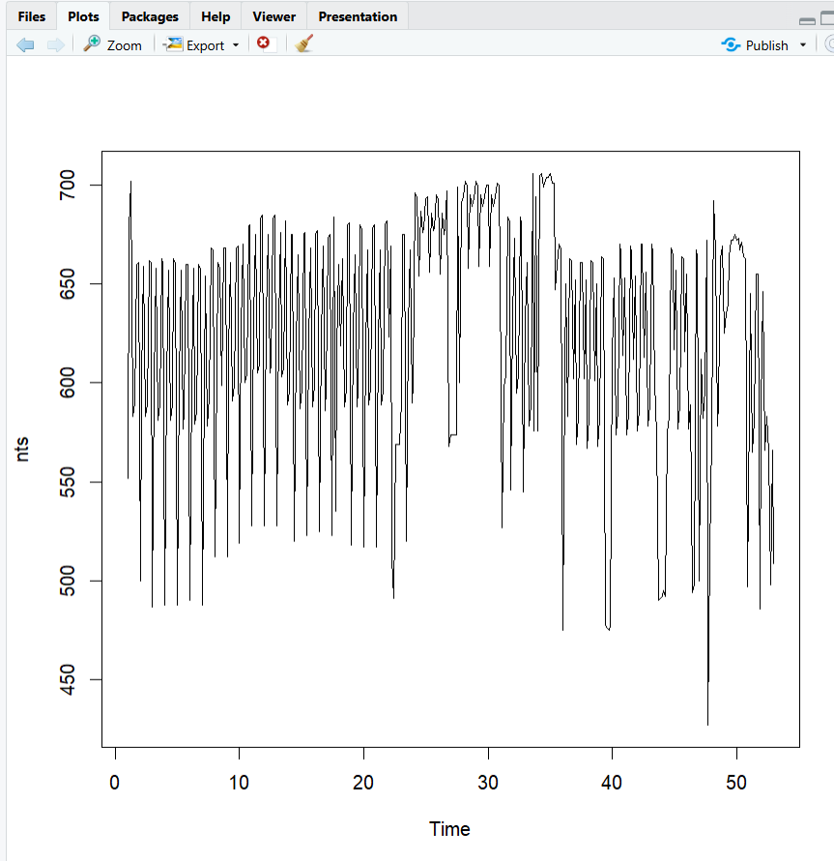

After this Plot output install a package
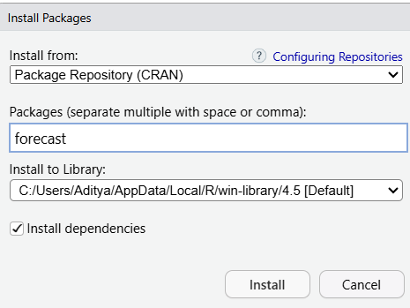

After installing the package again type in the output this line-
library(forecast) auto.arima(nts)
This will show you different output-
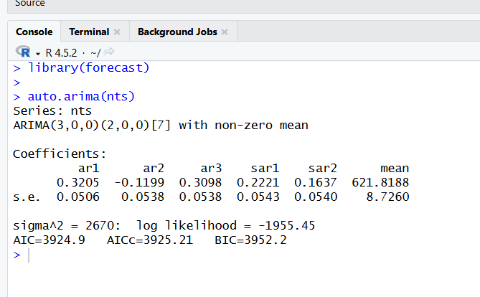

After this again type in the output this line-
auto.arima(nts, approximation = FALSE)

This will give you output-
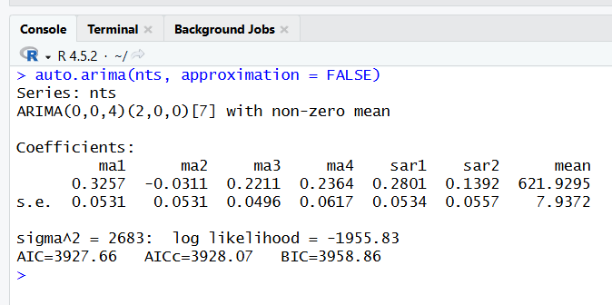

After this again type in the output this line-
fit <- HoltWinters(nts) plot(fit)

This will give you the different plot output-
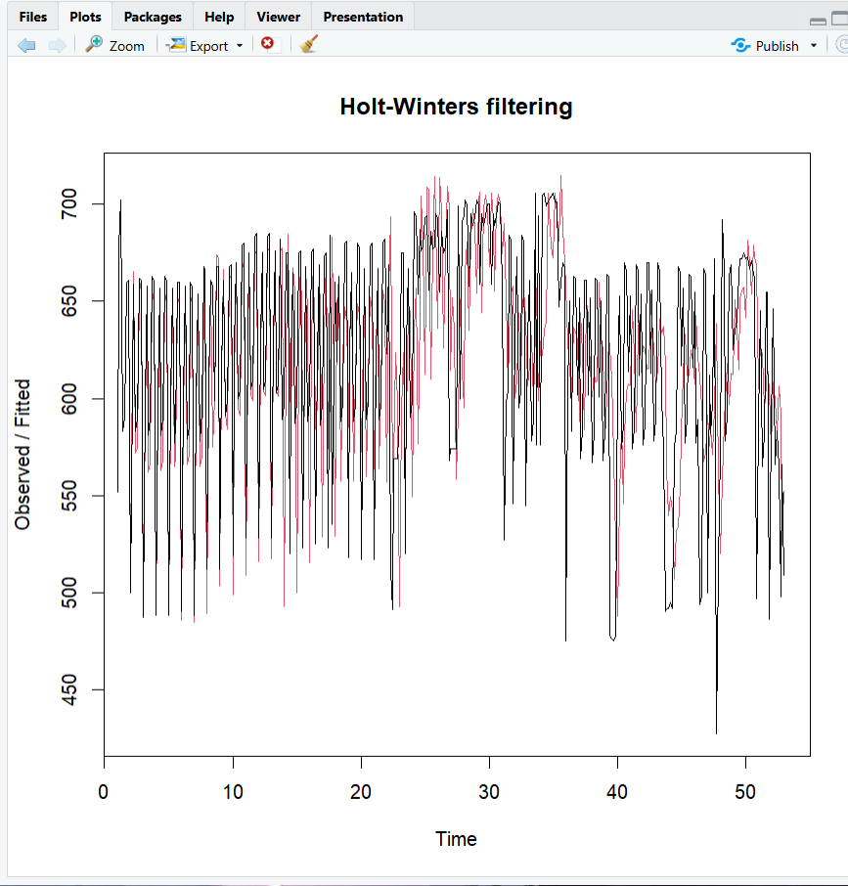

Again type in the output this line-
library(forecast) forecast(fit)
This will show you the output-
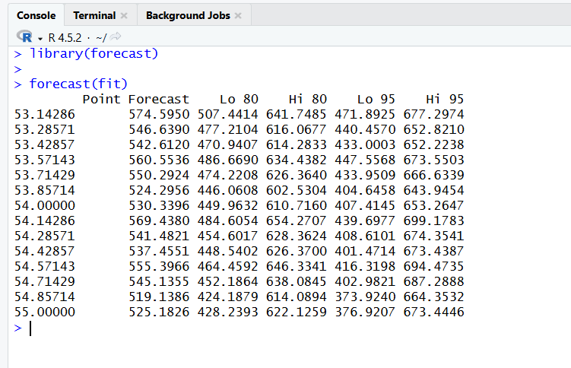
Again type in the output this line-
f <- forecast(HoltWinters(nts), 5) f
This will show you the output-
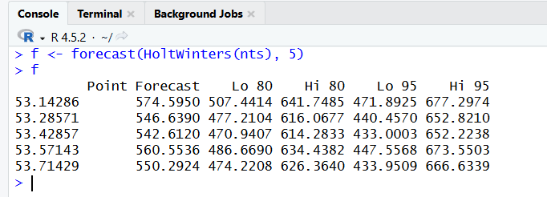

After this again type in the output-
library(forecast)

nts <- ts(daily$N, frequency = 7) fit <- HoltWinters(nts)
f <- forecast(fit, 5) plot(f)
This will give you the plot output-
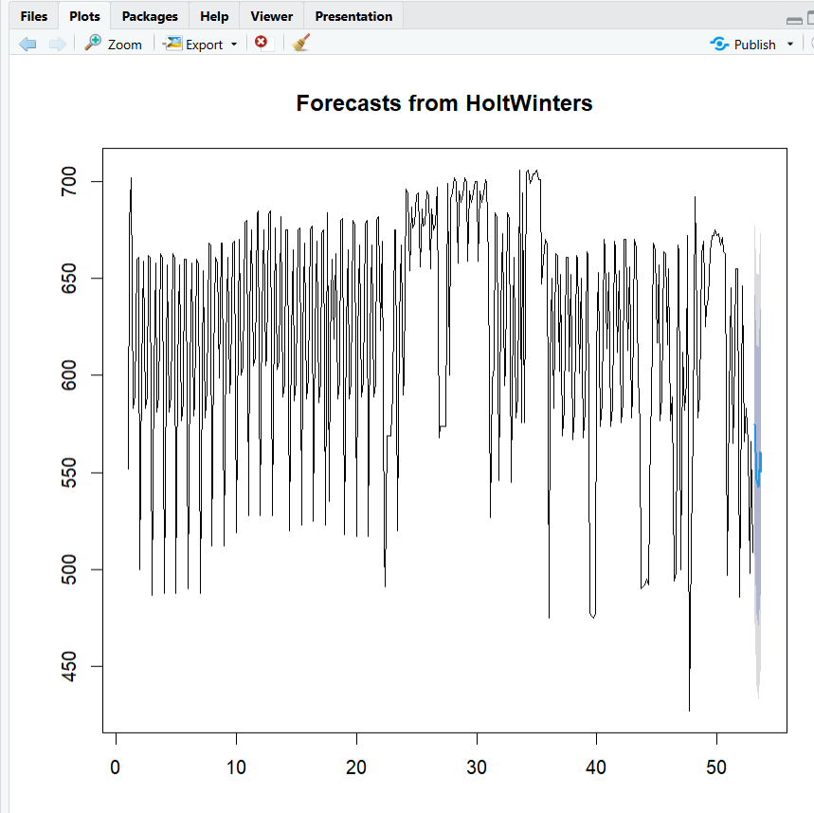

Again type in the output this line-
cts <- ts(daily$Cancelled) fit <- auto.arima(cts) auto.arima(cts)
This will give you the output-
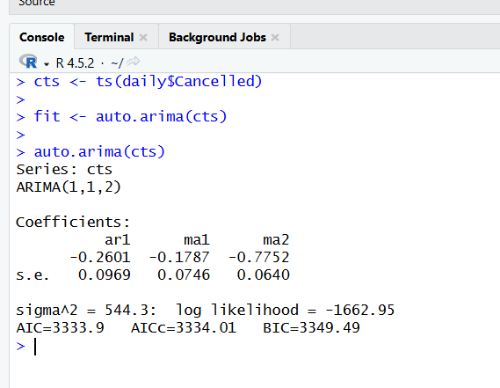

After this install a package-
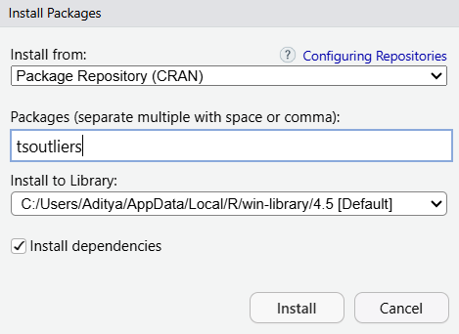

Then again type in the output this line -
library(tsoutliers)

outliers <- tso( cts,
tsmethod = "arima",
args.tsmethod = list(order = c(1, 1, 2))
)

outliers

OUTPUT-
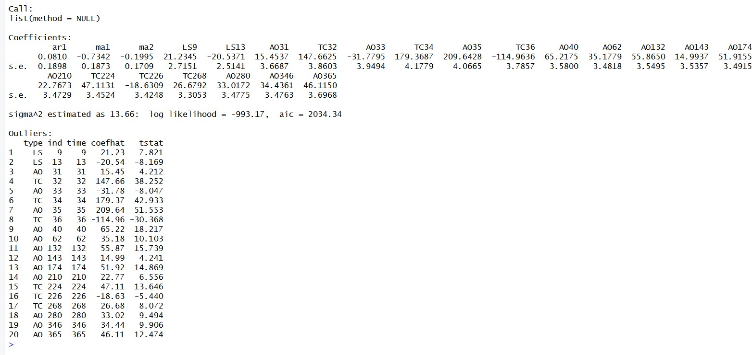

After this type this in output for plot output-
library(tsoutliers)
cts <- ts(daily$Cancelled) outliers <- tso(
cts,
tsmethod = "arima",
args.tsmethod = list(order = c(1, 1, 2))
)

plot(outliers) plot(tso(ts(daily$Cancelled)))

OUTPUT-
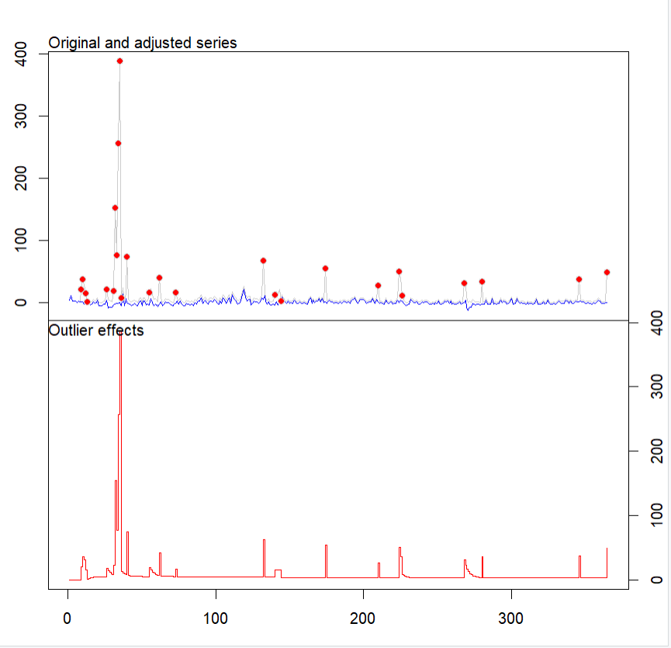

PRAC 8
Principal component analysis Code-
data("iris")

data_iris <- iris[, 1:4]

PCA_data <- princomp(data_iris, cor = FALSE) PCA_data$loadings[, 1:4]
summary(PCA_data) biplot(PCA_data)
screeplot(PCA_data, type = "lines") data(iris)

data_iris <- iris[, 1:4]

PCA_data <- princomp(data_iris, cor = FALSE) biplot(PCA_data)

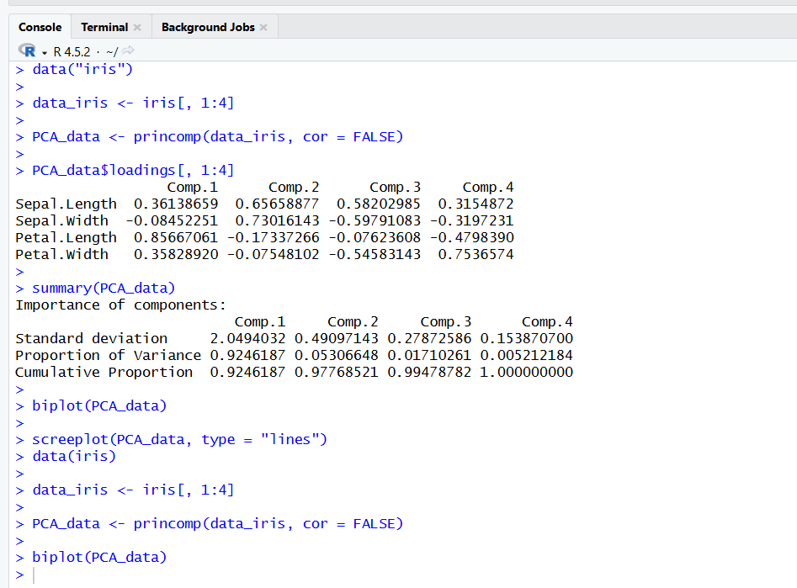
OUTPUT-

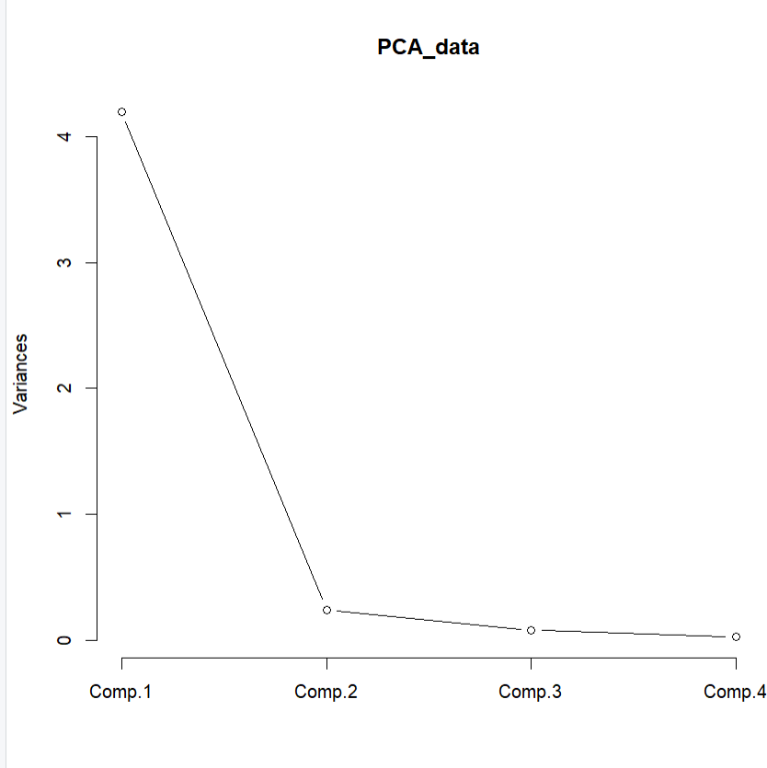
Plot output-

